# GPA

# TRACKING

# SOFTWARE

**Group Members**

# **Contents**

# **0.Contents………………………………………………………………………………….3**

# **1.Introduction……………………………………………………………………………...4**

**2.Requirements……………………………………………………………………………4**

**3.Constraints………………………………………………………………………………4**

**4.Inputs……………………………………………………………………………………4**

**5.Output……………………………………………………………………………………4**

**6.Object Oriented Analysis………………………………………………………………6**

**7.Flow Diagram…………………………………………………………………………...7**

**8.Use Case Diagram………………………………………………………………………8**

# **1.Introduction**

Having a good GPA is the goal of every university student. One of the key characteristics of setting a goal is that it should be measurable, or the progress made towards achieving it should be measurable. However, in UNESWA students only became aware of their grade point average when they receive their end of academic period results. For this reason, most students live in a throw and hope academic sphere as opposed to a healthy academic space where students take aim and achieve clearly defined and measurable goals. Having defined goals enforces the keenness and enthusiasm to achieve them and keeps one engaged. Students who set goals and can measure their progress are not only more like to achieve them but also perform comparably better than those who do not. Consequently, those who set measurable academic goals end up with less academic fatigue and anxiety as they can measure their progress in real time.

Purpose of the project

We propose to design and implement a cross-platform application to assist students in tracking their approximate grade point average and academic progress from their first test or assessment to their first exam paper. The application will allow students to set their academic period goal in grade points and track their progress as they write their assessments for the academic period. The goal is to determine the progress the student has made and the effort that must be made in order to achieve the initially set goal.

Purpose of the document

The purpose of this document is to give clear details as to how the application will work according to its inputs, functions and its outputs and how the app will be designed. It displays use cases, sequential and activity diagrams. Class diagrams will be used as a guide as to how the programmer can implement the models.

**2.Requirements**

Using an assessment weighting sheet, the application will process assessments scores added by the user per course. Each course has assessments that contribute to the final grade of the course and used to determine the average mark for the grade. for remaining assessments that the student needs to obtain in order to achieve their set grade point average for a set base exam score.

**3.Constraints**

-The student must have an up to date assessment weight sheet from instructors

-The student must regularly update his marks after every assessment

-The student must have either a laptop or have a smart phone running on android/IOS/MS windows/mac O in order to use the application.

**4.Inputs**

-Student marks.

-Weight sheet.

**5.Output**

-Current GPA.

-Marks needed to achieve goal.

**6.Object Oriented Analysis**

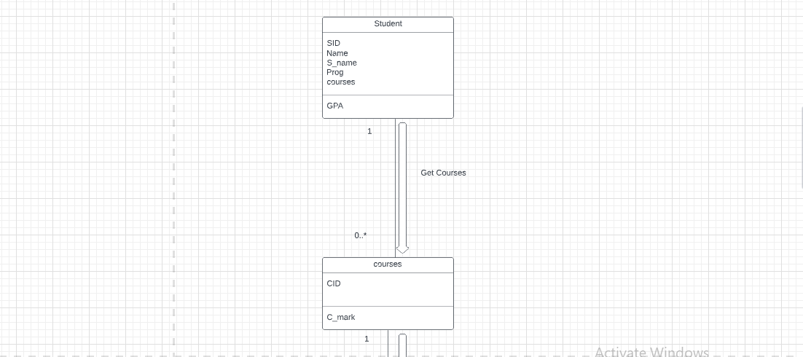

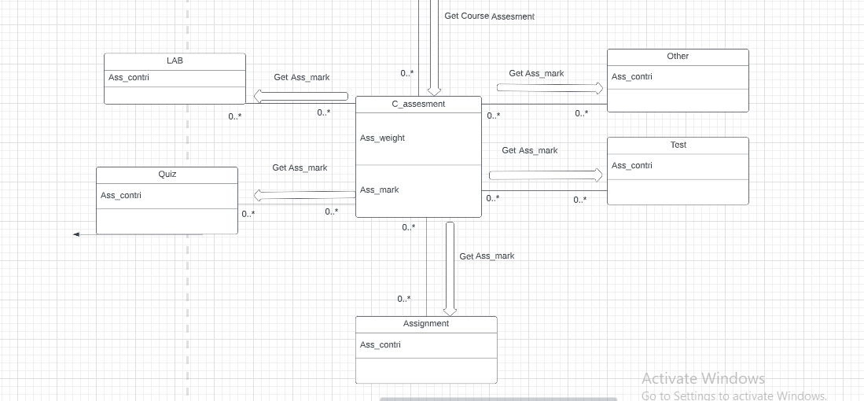

**7.Flow Diagram**

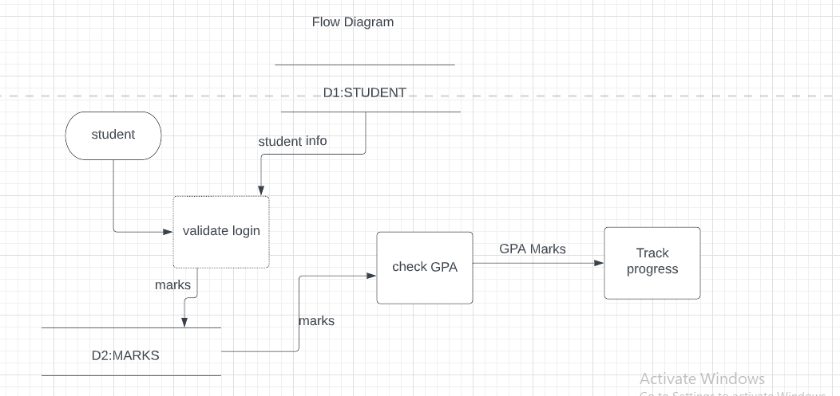

**8.Use Case Diagram**

